RESOLUTION NO.__________

RE: CERTIFICATE OF APPROPRIATENESS UNDER THE
PROVISIONS OF THE ACT OF THE PENNSYLVANIA
LEGISLATURE 1961, JUNE 13, P.L. 282 (53
SECTION 8004) AND BETHLEHEM ORDINANCE NO.
3952 AS AMENDED.

WHEREAS, it is proposed to install a fence at 217 Broadway.
.

NOW, THEREFORE, BE IT RESOLVED by the Council of the City of Bethlehem that a Certificate of Appropriateness is hereby granted for the work.

Sponsored by: (s)

(s)

ADOPTED BY COUNCIL THIS DAY OF

(s)
President of Council

ATTEST:

(s)
City Clerk

HISTORIC CONSERVATION COMMISSION

CASE # 407 – It is proposed to install a new fence at 217 Broadway.
OWNER/APPLICANT: Greg Salamoni/ John Lee

The Commission upon motion by Ms. Starbuck and seconded by Mr. Heitmann adopted the proposal that City Council issue a Certificate of Appropriateness for the proposed work described herein:

- The proposal to install a new fence at 217 Broadway was presented by John Lee and Greg Salamoni.

- The fence will be along the left side of the building parallel to the parking lot curb. At the front sidewalk the fence will return to the building, and a gate will be located in the return.

- The fence will consist of #1 grade 5/4 x 6 pressure treated horizontal boards with gaps of approximately 1/2”. The fence boards will be 12’ long and the joints will be staggered.

- Fence posts will be 4” metal and be located on the inside of the fence at approximately 6’ intervals.

- The top of the fence will be finished off with a horizontal cap board.

- The fence will be stained and sealed.

- The new fence design will be as discussed at the meeting, but details of the fence must be mocked up for the HCC to see at an onsite meeting. Some adjustments to the fence details may occur at the site meeting.

- The proposed motion was unanimously approved.

CU: cu

By: 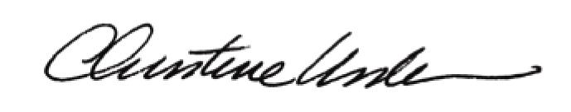

Date of Meeting: March 19, 2012 Title: Historic Officer

